Aim: To study Preprocessing of text (Tokenization. Filtration, Script Validation, Stop Word Removal, Stemming)
IDE: Google Colab

Theory:
To preprocess your text simply means to bring your text into a form that is predictable and analyzable for your task. A task here is a combination of approach and domain. Machine Learning needs data in the numeric form. We basically used encoding technique (Bag Of Word, Bi-gram, n-gram, TF-IDF, Word2Vec) to encode text into numeric vector. But before encoding we first need to clean the text data and this process to prepare (or clean) text data before encoding is called text preprocessing, this is the very first step to solve the NLP problems.

Tokenization:
Tokenization is about splitting strings of text into smaller pieces, or "tokens". Paragraphs can be tokenized into sentences and sentences can be tokenized into words.

Filtration:
Similarly, if we are doing simple word counts, or trying to visualize our text with a word cloud, stopwords are sonic of the most frequently occurring words but don't really tell us anything. We're often better off tossing the stopwords out of the text. By checking the Filter Stopwords option in the Text Pre-processing tool, you can automatically filter these words out.

Stemming:
Stemming is the process of reducing inflection in words (e.g. troubled, troubles) to their root form (e.g. trouble). The "root" in this case may not be a real root word, but just a canonical form of the original word.

Stemming uses a crude heuristic process that chops off the ends of words in the hope of correctly
actually be converted to troublinstead of trouble because the ends were just chopped off (ughh, how crude!). There are different algorithms for stemming. The most common algorithm, which is also known to be empirically effective for English, is Porters Algorithm. Here is an example of stemming in action with Porter Stemmer:

original word stemmed words
0 connect connect
'I connected connect
- connection connect
- connections connect
- connects connect

Stopword Removal
Stop words are a set of commonly used words in a language. Examples of stop words in English are "a", ‘‘the", "is", "are" and etc. The intuition behind using stop words is that, by removing low information words from text, we can focus on the important words instead.
For example, in the context of a search system, if your search query is 'what is text preprocessing?", you want the search system to focus on surfacing documents that talk about text preprocessing over documents that talk about what is. This can be done by preventing all words from your stop word list from being analyzed. Stop words are commonly applied in search systems, text classification applications, topic modeling, topic extraction and others. Stop word removal, while effective in search and topic extraction systems, showed to be non-critical in classification systems. However, it does help reduce the number of features in consideration which helps keep your models decently sized

Program (Code):

#NLP

text="""Gouri Unnithan is from electronics background and she recently gave EC GATE Exam in Methoda, Rajkot on 15th Feb 2026 from 9:30 - 12:30 which was moderate-difficuilt level of difficuilty."""

type(text)

text[5]

#NPL: SPACY, NLTK, Gensim

import spacy

#load the language model

nlp=spacy.load('en_core_web_sm')

doc=nlp(text)

type(doc)

doc[5]

#Named Entity Recognition: NER

for token in doc.ents:

print(token.text, token.label_)

#POS tags: Part of speech tagging

for token in doc:

print(token.text, "-->", token.pos_)

#converts a word to root form

#stemming vs lemmatization

text="""I studied AI subject and then meeting Mr. Sachin in a meeting"""

#stemming

import nltk

from nltk.stem.porter import *

p_stem=PorterStemmer()

for word in text.split():

print(word,"-->",p_stem.stem(word))

#lemmatization

for token in nlp(text):

print(token.text,"-> ",token.pos_,

"->",token.lemma_)

Results:

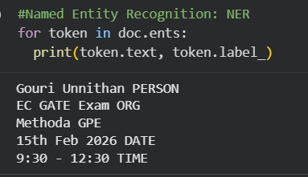

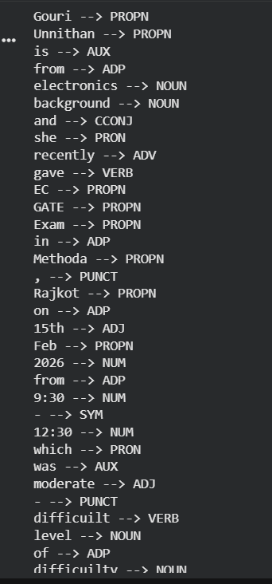

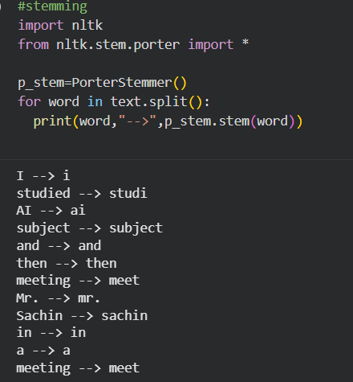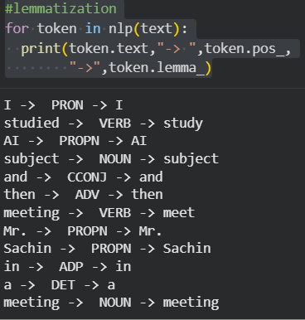

Observation:

Stemming removes suffixes using rules and may produce incorrect words, while lemmatization converts words into meaningful root words using vocabulary and grammar. Lemmatization is more accurate but slower than stemming.

Post Lab Exercise:
- Take your own document of 10 sentences and perform the same tasks. Attach code and screenshot of your output.
- Write your observation for stemming and lemmatization you obtained for the sentences.

Code:
text = """
Machine learning is used in many applications.
Artificial intelligence is changing the world.
Students are learning programming languages.
Engineers are developing smart systems.
Data science helps in prediction and analysis.
Deep learning models require large datasets.
Natural language processing understands human language.
Researchers are studying advanced algorithms.
Technology is growing very fast.
Computers are becoming more powerful day by day.
"""
# Import libraries
import spacy
import nltk
from nltk.stem.porter import PorterStemmer
from nltk.corpus import stopwords

# Load spacy model
nlp = spacy.load("en_core_web_sm")

# Create document
doc = nlp(text)

# Tokenization
print("Tokenization:")
for token in doc:
print(token.text)

# Stopword Removal
print("\nAfter Stopword Removal:")
for token in doc:
if not token.is_stop:
print(token.text)

# Stemming
print("\nStemming:")
stemmer = PorterStemmer()

for word in text.split():
print(word, "->", stemmer.stem(word))

# Lemmatization
print("\nLemmatization:")
for token in doc:
print(token.text, "->", token.lemma_)

# POS tagging
print("\nPOS Tagging:")
for token in doc:
print(token.text, "->", token.pos_)

Output:

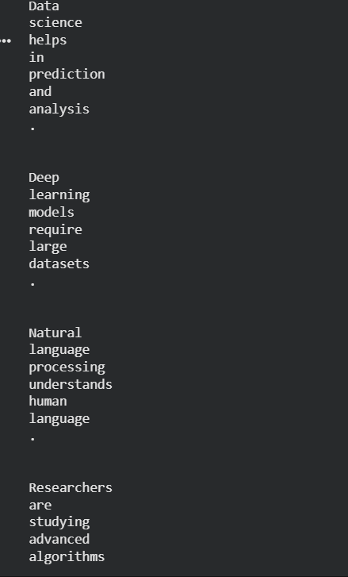
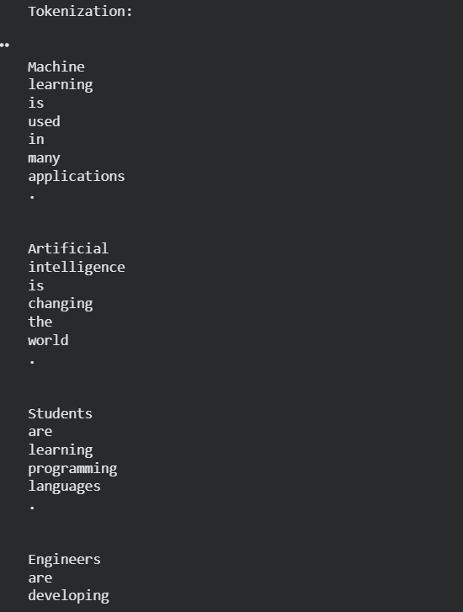

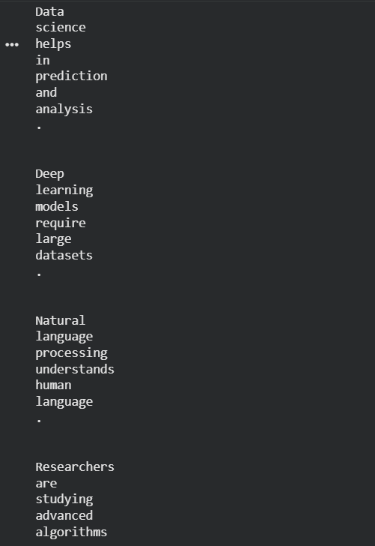

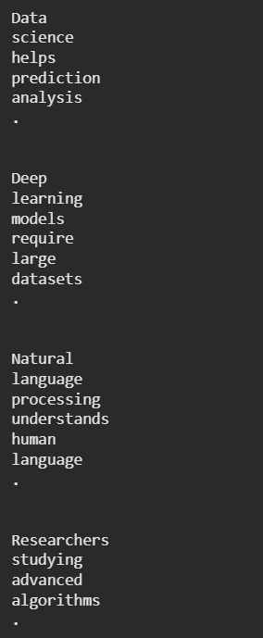
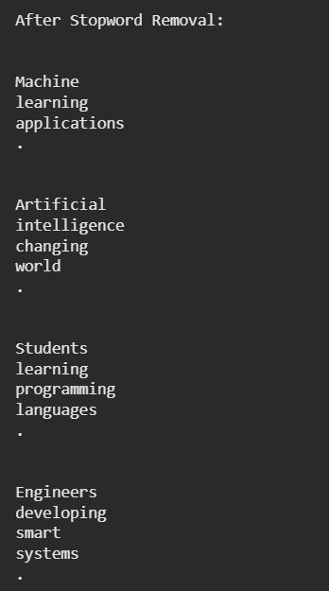

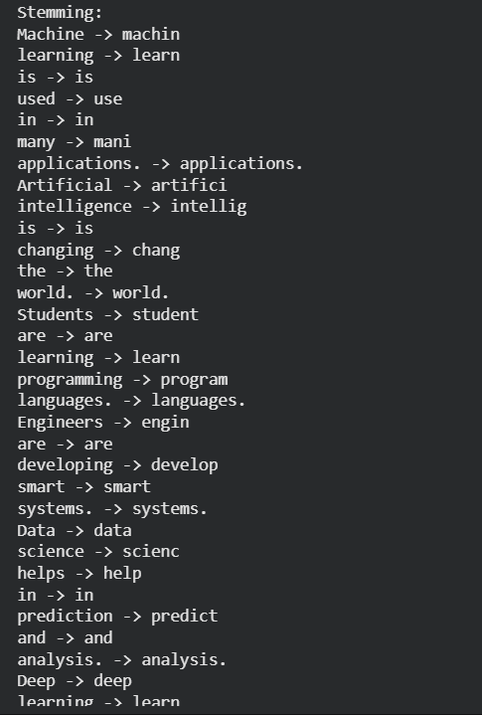
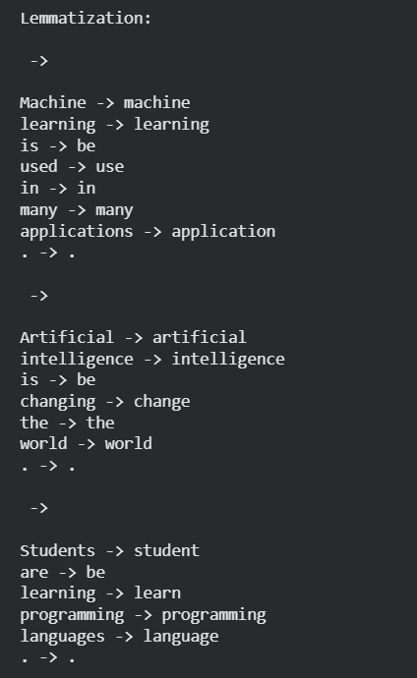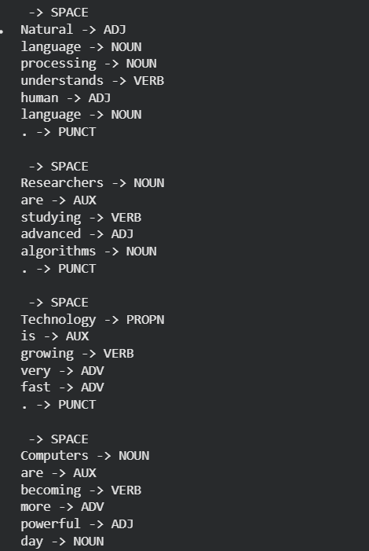

Observation:
• Stemming removes suffixes from words using simple rules.
• Sometimes stemming produces incomplete or incorrect words.
• Lemmatization converts words into meaningful base form using vocabulary and grammar rules.
• Lemmatization gives correct dictionary words.

Conclusion:
Lemmatization is more accurate and meaningful compared to stemming, but stemming is faster. Both methods help reduce different forms of words into a single base word, which improves text analysis and reduces feature size in NLP models.

